Referring on to Early Discharge Team/CRHT

- Go to the ‘DHCFT WAA Inpatients Launch pad’
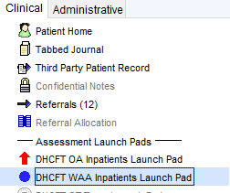

- Click on the ‘WAA referrals template’ (bottom right of the launch pad)

- Under the core teams, click on ‘refer to CRHT’ and complete the questionnaire
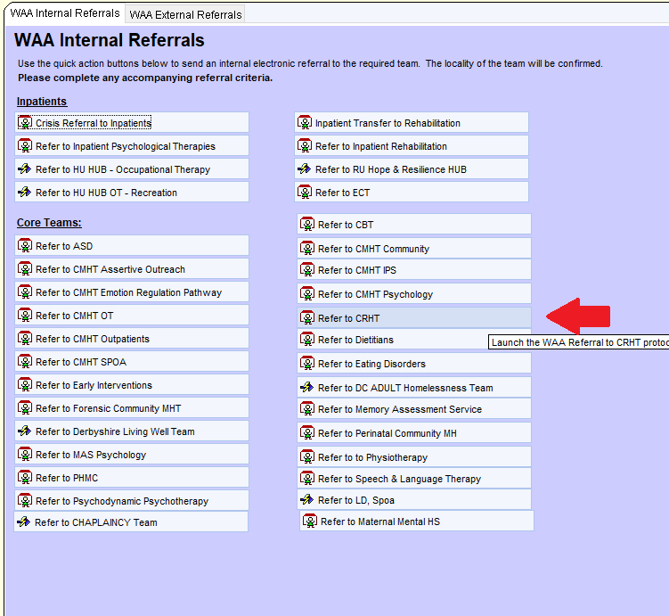
- A prompt re: a verbal discussion will pop update. Please ensure the referral has been first discussed with EDT. This could be in rapid review, in an MDM or in a phone call.
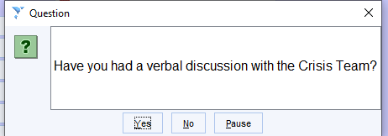

- Opens referral questionnaire – complete and save
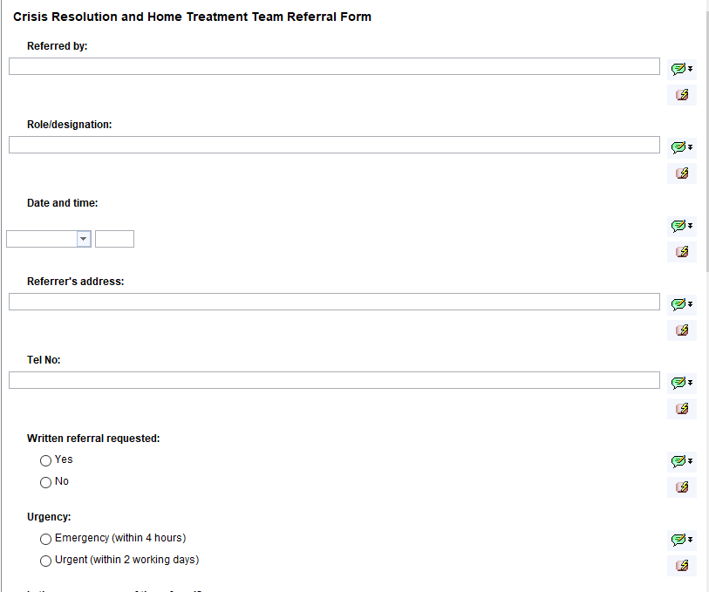

- Select which CRHT team you need
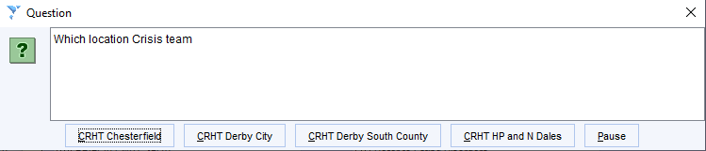

- You’ll be ask if you want to referral electronically – select ‘Yes’
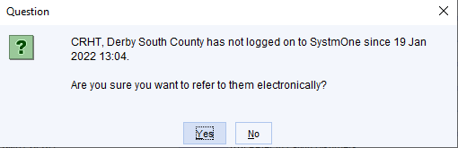

- Complete referral summary – i.e. ‘referral to EDT’

- Then complete the referral narrative – more detail re need/role/purpose i.e. to support leave period, for 2 day follow up’.
- Press ‘okay’ at the bottom of the box.
(Leave recipient ID blank)
- Ensure you save via the green save button – the referral won’t be made until a main save is completed
